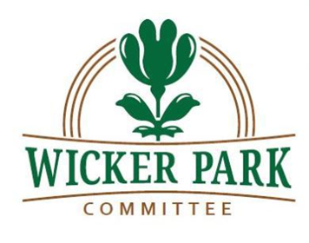
Wicker Park Committee
Membership Meeting Minutes
May 6, 2020
7:00 p.m.

Introductions and Welcome
Mr. Sneed welcomed the public and began the meeting at 7:04 p.m. At least voting 30 members of the Wicker Park Committee and public were present. He reminded the public about the ongoing US Census, and provided an update on COVID-19 testing currently available in the neighborhood. Mr. Sneed also thanked all participants for attending the meeting via videoconference, to remain in compliance with the city’s social distancing recommendations.
New Business
Mr. Young provided an update on the Committee’s website platform improvements, including the addition of JoinIt for membership management and annual dues payments.
Ms. Root reviewed a potential neighborhood initiative, Adopt A Business, and provided details on recent discussions with the East Village Association to work collaboratively on the initiative. She encouraged community members to reach out to Mr. Drutchas with suggestions regarding the initiative.
Wicker Park Business Spotlight: Volumes Bookcafe
Mr. Sneed introduced Ms. George, owner of Volumes Bookcafe. Ms. George reviewed the current state of business in Wicker Park in light of the COVID-19 pandemic, and expressed her concerns for the future viability of Volumes and neighboring businesses. Community members discussed the Milwaukee Ave business corridor with Ms. George, including the recent closure of several stores, and the anticipated demands of landlords in the community.
Ms. Yepez, owner of the Wicker Park Inn, discussed local business from the hospitality perspective, and echoed Ms. George’s sentiments.
Conversation with Congressman Quigley
Mr. Sneed introduced Congressman Mike Quigley. Rep. Quigley thanked the WPC for their time, and provided a brief review of current priorities of legislators around the state. He discussed the dissemination of stimulus checks, as well as the recently implemented CARES Act and the Paycheck Protection Program (PPP) loans provided to small businesses. Community members discussed the local economic effects of the COVID-19 pandemic being felt in the neighborhood in detail.

Rep. Quigley also discussed the upcoming presidential election and the push to allow voting by mail in all states.

New Business
Mr. Drutchas discussed a pilot program implemented in the city of Chicago in 2016 for curbside café eating. While not entirely successful at the time, Mr. Drutchas expressed an interest in revitalizing the program with modifications during the Pandemic, as a means of restarting local businesses. Community members discussed the program in detail, and expressed their support of reaching out to the Alderman for further discussion.
Preservation and Development
Mr. Tamminga discussed upcoming and anticipated zoning change discussions, including a proposed cannabis store within the neighborhood. He advised that the city’s Zoning Committee is currently meeting virtually.

Mr. Sneed asked the community for their preferences on the WPC website address. Community members were in support of continuing with the use of the current .com address.

There being no further business, the meeting ended at 8:29 p.m.

