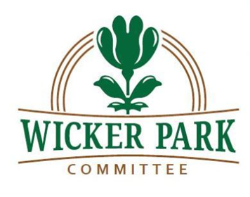

Wicker Park Committee
Membership Meeting Minutes
March 4, 2020
7:00 p.m.

Welcome and Announcements
Mr. Sneed welcomed the public and began the meeting at 7:03 p.m. At least voting 35 members of the Wicker Park Committee and public were present. Mr. Sneed reviewed several upcoming community events, and encouraged participants to become involved in the community.
Wicker Park Business Spotlight: SBK Dog Club
A representative from SBK Dog Club provided a brief review of the services offered through the company, including personalized pet boarding and varying schedule accommodations. A discount was offered to neighbors living within the 60622 zip code.

Preservation Chicago
Ward Miller, Executive Director of Preservation Chicago, spoke on preservation themes and issues within the Wicker Park community. Mr. Miller further discussed endangered buildings within the city of Chicago, as well as recent ordinances proposed by Alderman Hopkins in order to reduce property neglect.

Ukrainian Village Update
Kimberly Shannon, a representative of the Ukrainian Village Neighborhood Association, reviewed the UVNA’s desire to extend a landmark district on Augusta Avenue between Leavitt St. and Damen Ave. She asked for support from the neighboring Associations in order to preserve the landmark district, and specifically requested support regarding 2047 W. Augusta Ave. Community members present at the meeting thanked Ms. Shannon for her work and advised of their support of her efforts. Mr. Tamminga noted that a letter would be provided to Alderman Hopkins in support of the landmark district extension.

Preservation & Development

1462 N. Ashland: Discussion was held on the current liquor moratorium present on N. Ashland Avenue. A representative of The Comedy Clubhouse provided background regarding the business’s request through the city to grant an exception to the moratorium, and advised that the Clubhouse works with many charities, and provides funding and support for multiple organizations for developing comedians. The representative advised that without the ability to obtain a liquor license, the business may not survive. Mr. Tamminga advised that if a vote by the WPC supported The Comedy Clubhouse’s request to lift the liquor moratorium, that a public meeting would be held with Alderman Hopkins regarding the issue.

A vote was conducted on supporting a lift of the liquor moratorium for 1462 N. Ashland Ave. The vote passed with the following votes:

21 Ayes
0 Nays
0 Abstentions

1302 N. Milwaukee Ave: Discussion was held on the request to temporarily rezone the property to C1-3 from the existing B3-3 zoning, to allow for The Big Mini, a miniature gold company, to obtain a liquor license and building permit. It was advised that the property would be rezoned to B3-3 when renovations were complete.

A vote was conducted on supporting a lift of the liquor moratorium for 1462 N. Ashland Ave. The vote passed with the following votes:

21 Ayes
0 Nays
0 Abstentions

There being no further business, the meeting ended at 8:30 p.m.

